Syed Nasif Ali (201304650)

Lab 3: Exercise

<https://studio.code.org/s/course4/stage/12/puzzle/3>

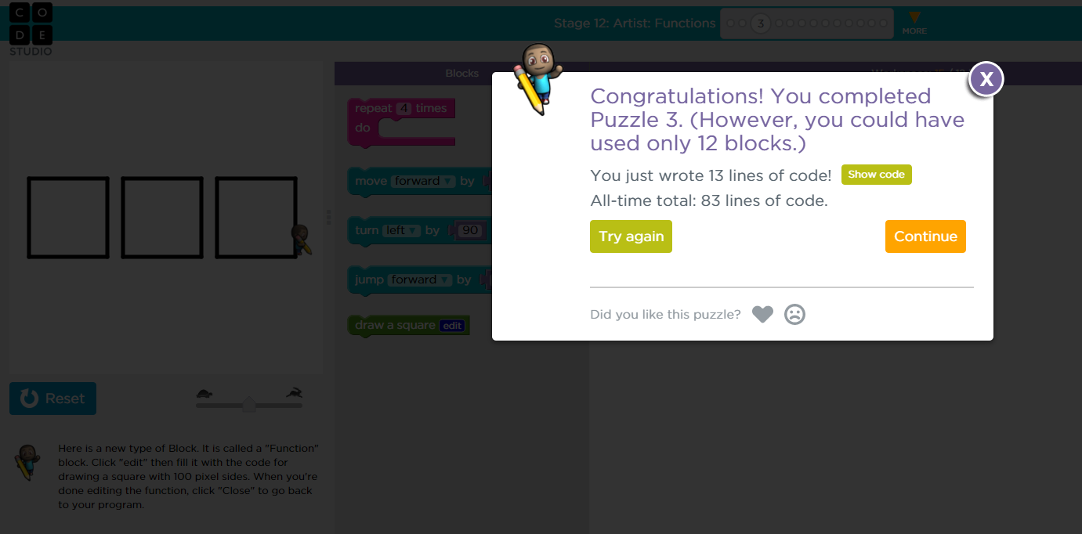

<https://studio.code.org/s/course4/stage/12/puzzle/6>

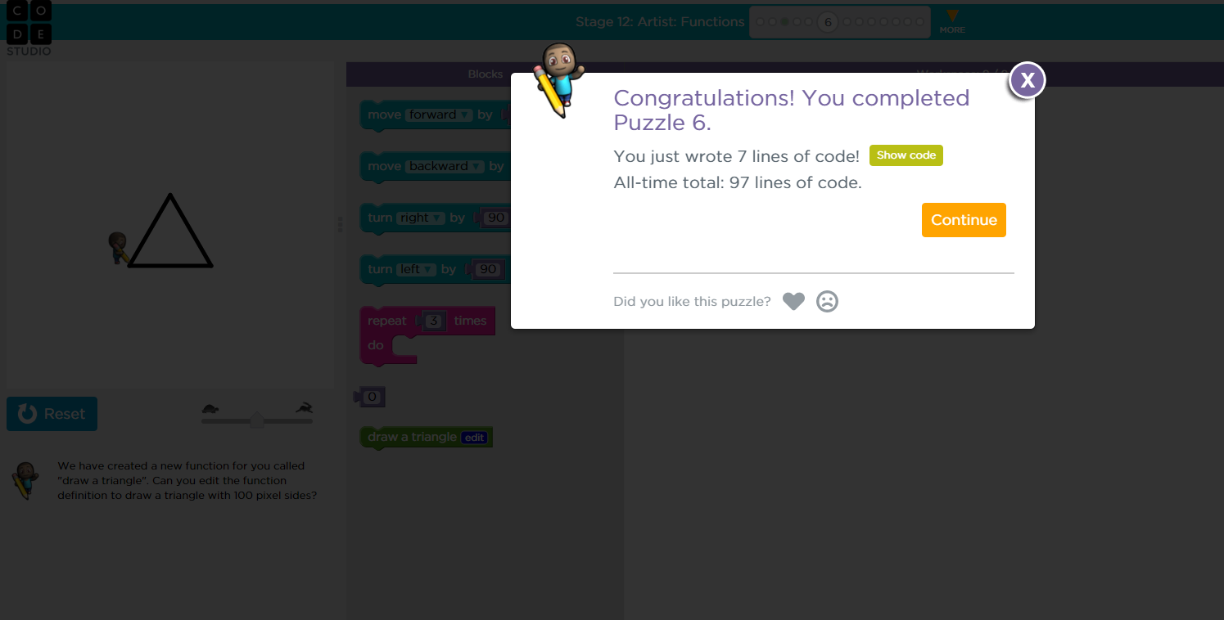

<https://studio.code.org/s/course4/stage/12/puzzle/7>

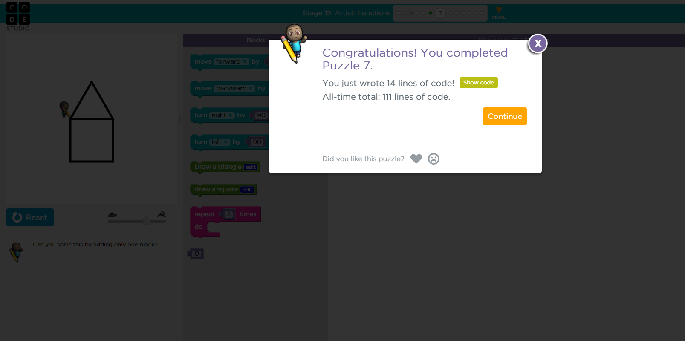

<https://studio.code.org/s/course4/stage/14/puzzle/3>

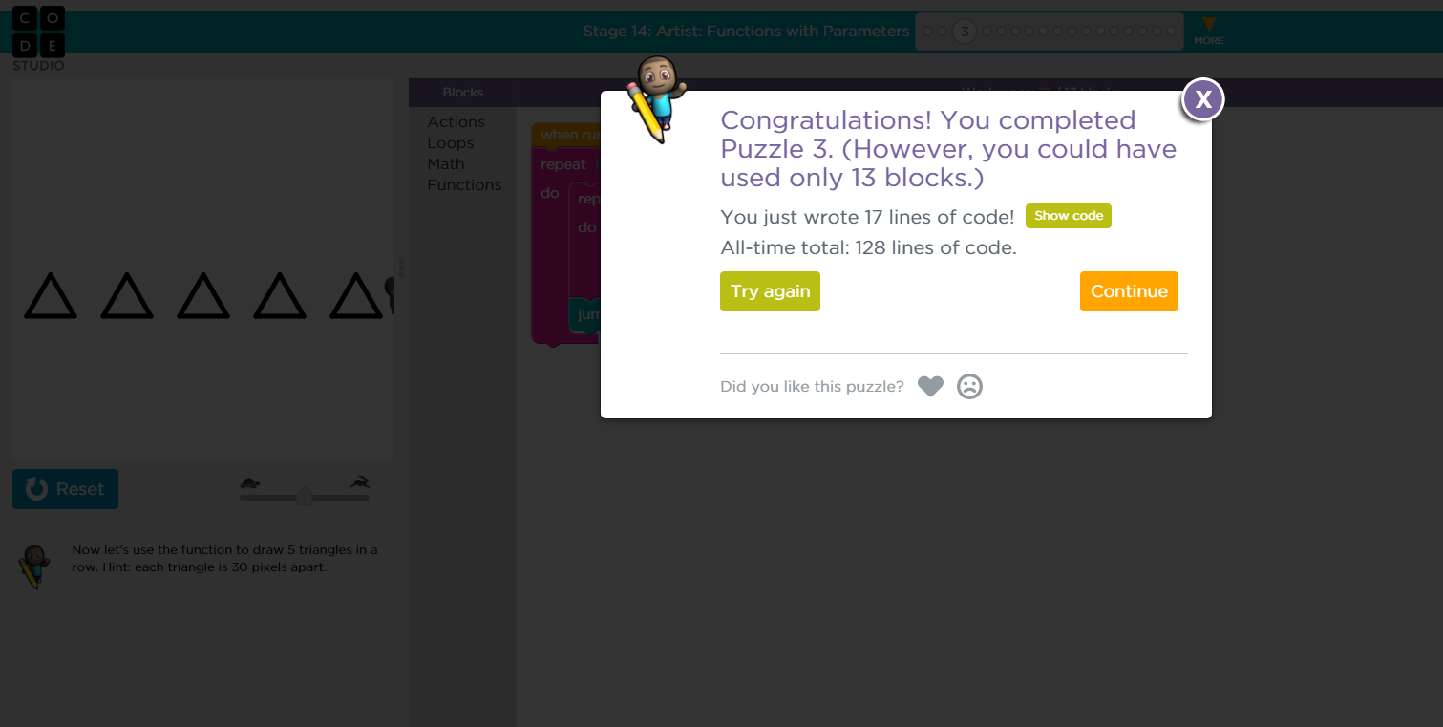

<https://studio.code.org/s/course4/stage/14/puzzle/4>

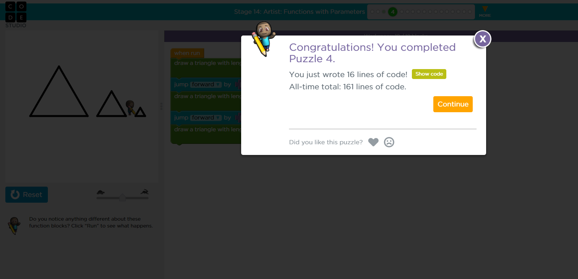

<https://studio.code.org/s/course4/stage/14/puzzle/5>

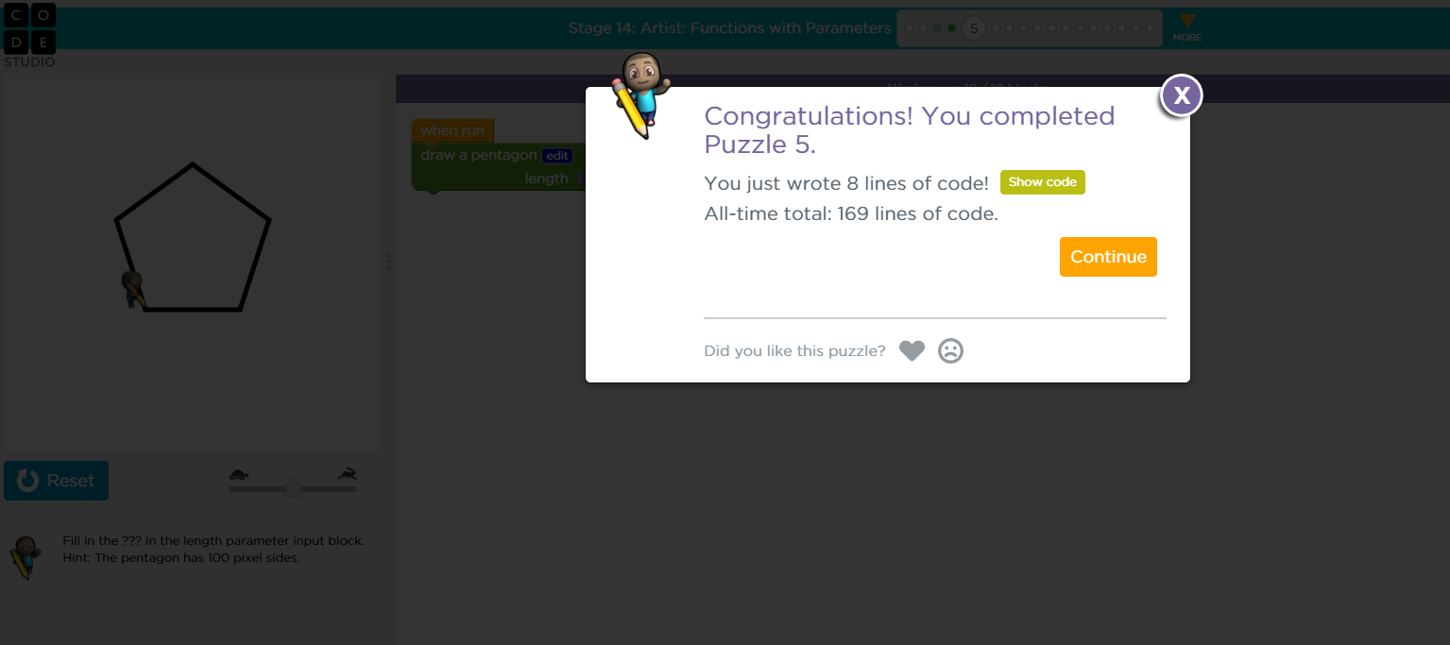

<https://studio.code.org/s/course4/stage/14/puzzle/6>

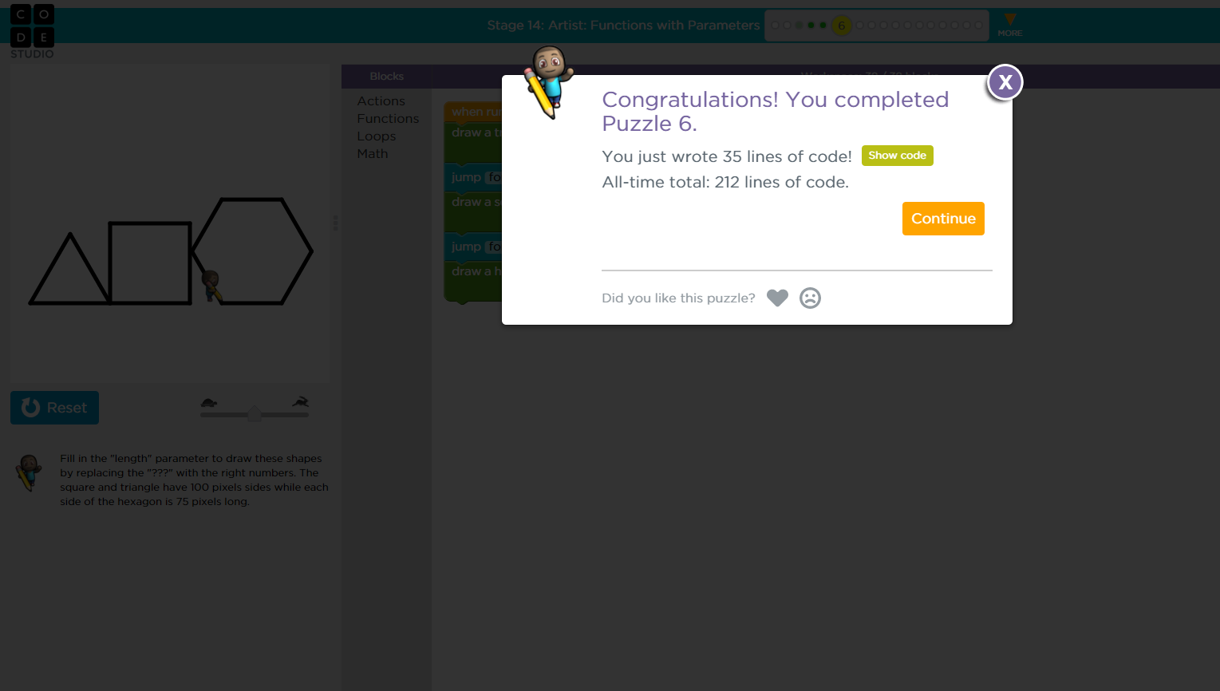

<https://studio.code.org/s/course4/stage/12/puzzle/9>

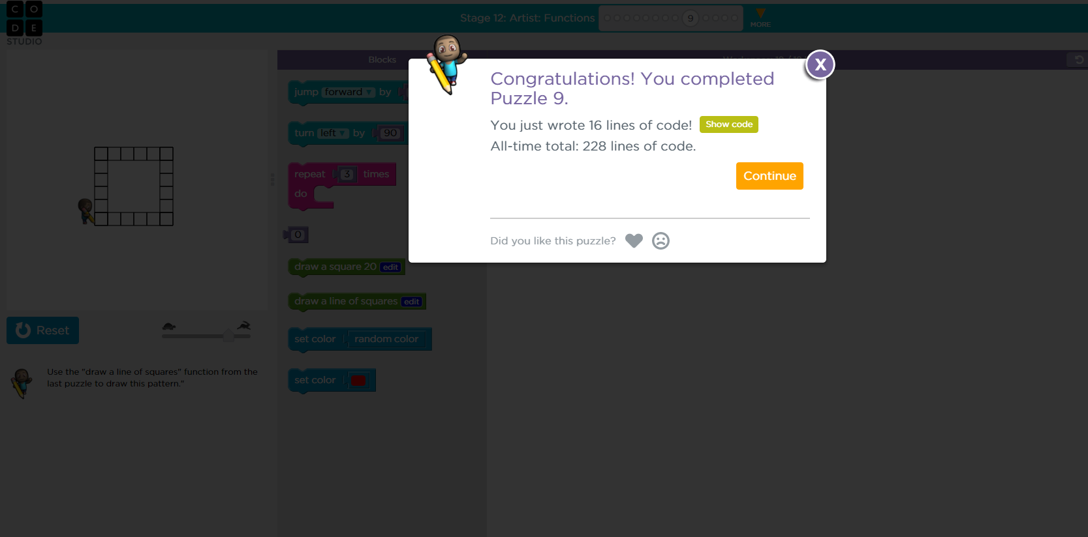

<https://studio.code.org/s/course4/stage/14/puzzle/7>

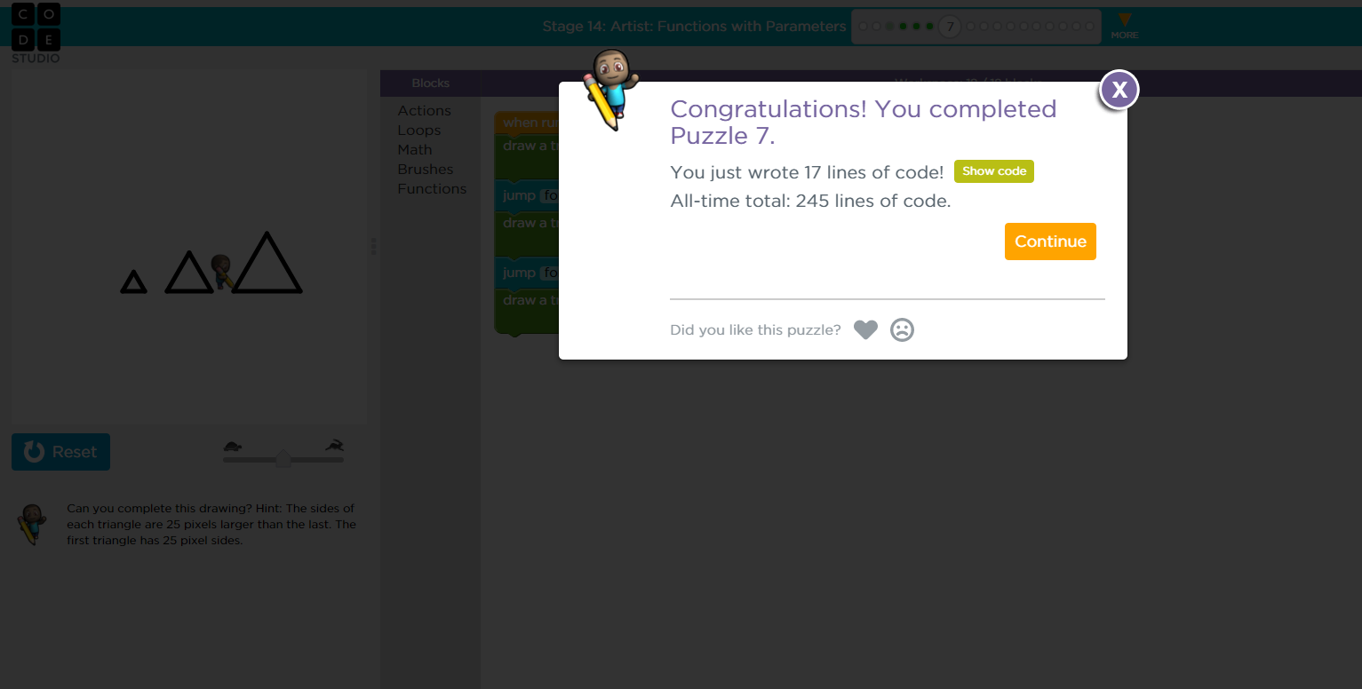

<https://studio.code.org/s/course4/stage/14/puzzle/8>

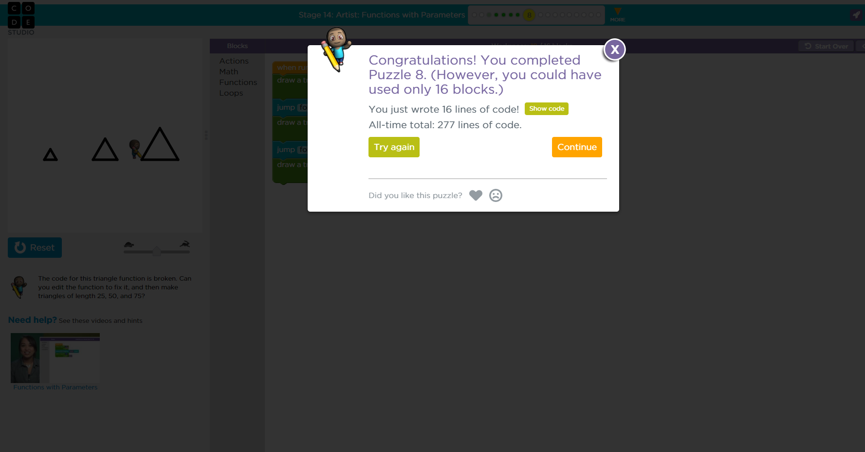

<https://studio.code.org/s/course4/stage/14/puzzle/10>

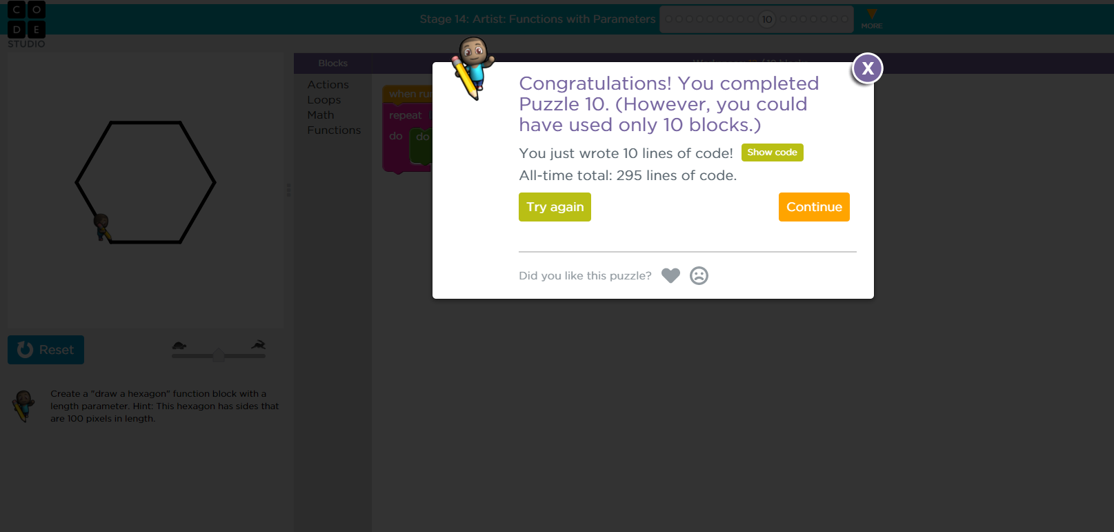

<https://studio.code.org/s/course4/stage/14/puzzle/14>

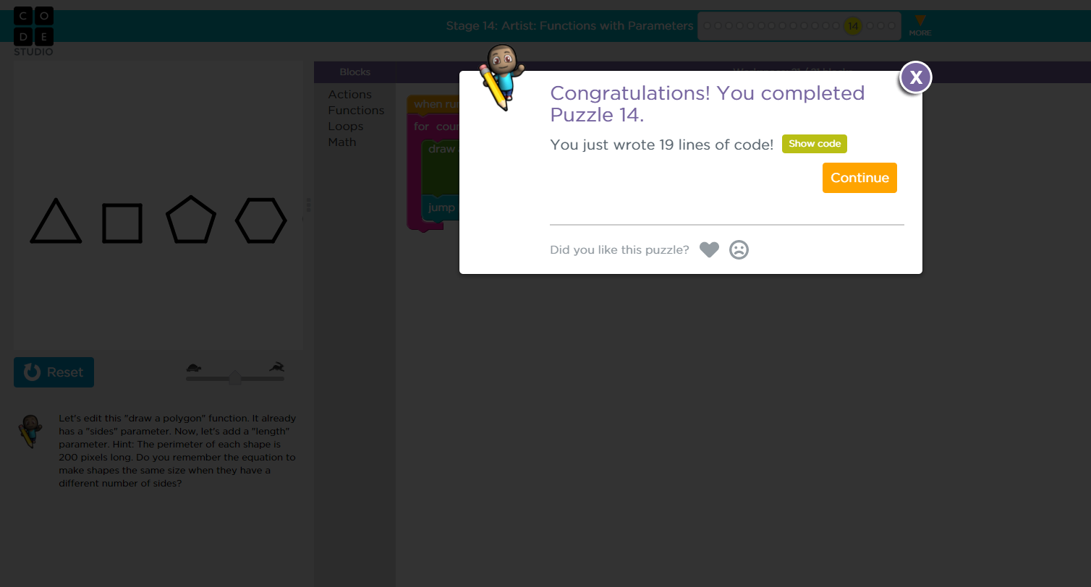

<https://studio.code.org/s/course4/stage/14/puzzle/15>

